MYONGJI
UNIVERSITY
Guideline for 2022 Fall
Exchange Program

Important Notice due to COVID-19

- Information contained here is subject to change as COVID-19 continues to present us with significant uncertainty.
- English-taught Programs: If the 2022 Fall semester will be offered online, the number of English-taught courses will be very limited as most of English-taught programs require active discussions among students and close interactions between faculty and students, which we find quite challenging to implement when courses were offered online.
- [As of December 2021] 10 days quarantine for all inbound travelers entering Korea : In view of the COVID-19 pandemic, all inbound travelers (including returning Korean nationals) are required to quarantine themselves for 10 days upon their arrival in Korea. If this policy continues, your students will need to abide by the 10 days quarantine upon their arrival in Korea.

※ All in-person activities, such as Orientation and Check-in, may be replaced with alternative methods
(i.e. emails, online materials, or virtual meetings) depending on the future situation with COVID-19.

Qualifications

Students must:
① Be officially nominated by the home university and completed at least 1 academic year in the home
university.
② Meet at least 1 of the followings:
- Already obtained at least TOPIK Level 3
- TOEFL IBT 70 or above (or IELTS 5.5, TOEFL ITP 527, TOEIC 750 ) OR proved by the home university for excellent level of English language skills
- Students who have not taken TOPIK but can prove their Korean language proficiency (prior to their arrival in Korea, special examination will be available online to these students).

Application Procedure
- Student contacts the international office of his/her home university to start the application procedure.
- The home university’s international office nominates applicants to MJU via email by end of April.
- MJU issues the Certificate of Admission, Letter of Acceptance and other related materials by mid-
June. (Post mailed to the international office of the student’s home university).
- Students apply for a visa in his/her home country, purchase a flight ticket and insurance.

Required Documents

All documents should be uploaded either as a PDF or JPG.

Photos taken with mobile phones are not accepted.

Recommendation Form : professor / academic advisor / International office officer.

Health Report

Guardian (Parental) Consent Form : needs guardian’s handwritten signature

Certificate of Enrollment in English

Official Transcript in English with total average GPA

Passport and Identification Card

A copy of the first page of the passport - Upload the entire page without cut off.

Passport must be valid at least until 2024 March.

Colored ID Photo : 2 photo print version & a JPG file

An ID photo taken at a photo studio ONLY, MUST be white background (3.5cm×4.5cm). No selfie.

Please bring 2 photos with you when you come to Korea.

TOPIK, TOEFL, IELTS certificate, if applicable

Copy of Certificate of Travel Insurance purchased in your home country

The certificate of insurance which is effective from the day of your departure from your home country to approximately October 31, 2022. (Once you register for an official ID card, you will be automatically subscribed to the Korean National Health Service. You are required to be covered under a private insurance until your registration in Korea. Registration will take approximately in mid-late October.

You can submit this copy of insurance certificate after you receive a certificate of admission from MJU.

VISA
Once students receive the Letter of Acceptance, Certificate of Admission, Certificate of Business Registration, they must visit - at the earliest date possible - the nearest Korean embassy/consulate to apply for a student visa. Make sure you contact the embassy/consulate in advance to find out the required documents for a visa. Respective Korean embassy/consulates have sole discretion on the issuance of a visa, and Myongji University is not in the position to offer any support in this regards. It may take over three months in certain countries or different documents may be required depending on the country. Please DO NOT purchase your plane ticket until you obtain a visa (since there is no 100% guarantee that your visa will be issued in time).

Course Registration

Campus
- There are two campuses; Seoul and Yongin (divided by faculty). Students can only choose one campus. Depending on the student’s Korean proficiency, students can take following courses:

Korean or English language proficiency
TOPIK Level 3 or higher | ① Any undergraduate course (language of instruction: Korean) *some require prerequisite OR/AND  ② KLEC intensive Korean language courses (Fee-paying)
Students who have not taken TOPIK but can prove their Korean language proficiency | 교과목 학점 조건  한국어연습1 1 토픽 3급 이상  한국어연습2 1 토픽 4급 이상  한국어1 2 토픽 3급 이상  한국어2 2 토픽 4급 이상  중급한국어1 3 토픽 3급 이상  고급한국어1 3 토픽 4급 이상  *Tuition waived for these courses  *Students may take the Korean Language Test administered by Myongji  University. The testing fee is about USD 50, and further information about  the payment process will be provided later. (Test date: June 4, 2022, Saturday)
TOEFL IBT 70 or above (or IELTS 5.5, TOEFL ITP 527, TOEIC 750 | ① Any English-taught undergraduate course (some require prerequisite)  OR/AND  ② KLEC intensive Korean language courses (Fee-paying)
Does not meet language requirement | KLEC intensive Korean language courses (Fee-paying)
※ Exchange(Visiting) students must maintain a minimum of 12 credits per semester. The course registration for the first semester will be done by office of international affairs of MJU. You will be able to change [add/drop] your courses once the semester starts.

② KLEC Registration for Exchange Student

- Korean Language Education Center (KLEC) is available in both campuses. Composed of 4 semesters, each semester lasts for 12 weeks. Exchange students have an option to take either [KLEC 2022 fall course] or [KLEC 2022 spring course + KLEC 2022 winter course].

- Each KLEC semester is 6 credits. Depending on your period of enrollment in KLEC, the number of credits you can register will change because the total cannot exceed 17 (total = KLI + Regular undergraduate). For example,
[Example]
- If you take 1 semester of KLEC, which is 6 credits, the maximum credits you can register for undergraduate (major or elective) courses are 11, therefore.
[Case2]
- If you take 2 semesters of KLEC, which are 12 credits, the maximum credits you can register for undergraduate (major or elective) courses are 5, therefore.

- Tuition : 20% tuition reduction for exchange students per KLEC semester.
- Detailed information can be found: klec.mju.ac.kr

NHIS
Mandatory National Health Insurance Service(NHIS).
The Korean Government’s new health insurance policy requires all foreigners enrolled in programs offered by Korean institutions of higher education, which include Korean Language programs, undergraduate and graduate programs, to be subscribed to the National Health Insurance.

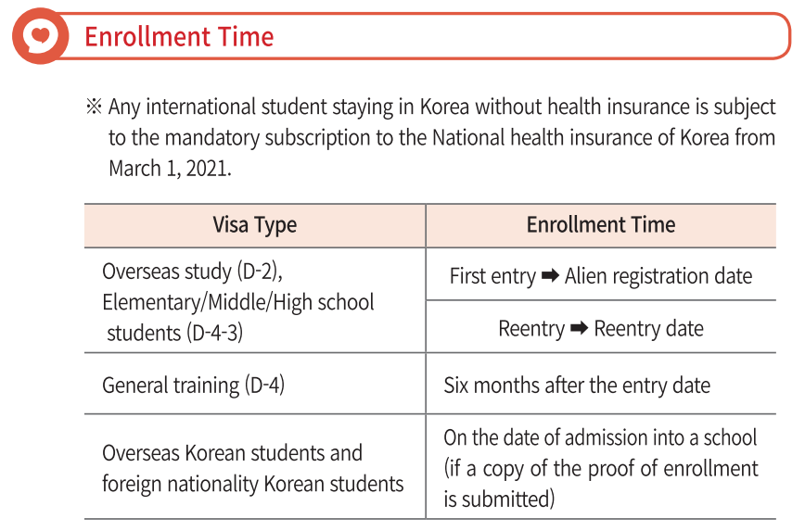

Click below links for the detailed information :

<ENG> https://youtu.be/cUC3B0BnJ5U
<VNM> https://youtu.be/cuNm9_hqGIM
<CHN> https://youtu.be/cLK7_lPAUR8

Promotional leaflet download :

https://www.nhis.or.kr/nhis/together/wbhaea01000m01.do?mode=view&articleNo=10804491&article.offset=0&articleLimit=10

